Precalculus Extended Learning
Our Learning Goals:

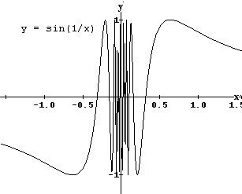

Additional Support:
- Check the teacher web pages for posted daily notes, worksheets, assignments, etc.

- Search the topic on the web. We recommend Khan Academy and Illuminations.

- Attend tutorials – you can see ANY math teacher for help.

We will…
- present findings in a variety of ways.
- calculate limits algebraically and graphically (PAP).
- interpret limits to define asymptotic behavior (PAP).

Why do we study this?
- We will have the opportunity to solve problems and present our findings. This section answers the age-old question, “When are we ever going to use this?”
- The study of limits will help us prepare for calculus at the high school or college level. It is essentially a study of “what if?” What if this pattern continues, what could we conclude? What if we could reach the input value of 3, what would be the output? (PAP)

How we will show what we have learned…
Formative Assessments | Summative Assessments
Ongoing formative assessments during lesson and homework activities will help in monitoring learning and providing feedback for students. | Summative assessments to measure learning at the end of concepts will include the following:  - Limit Test (PAP)

